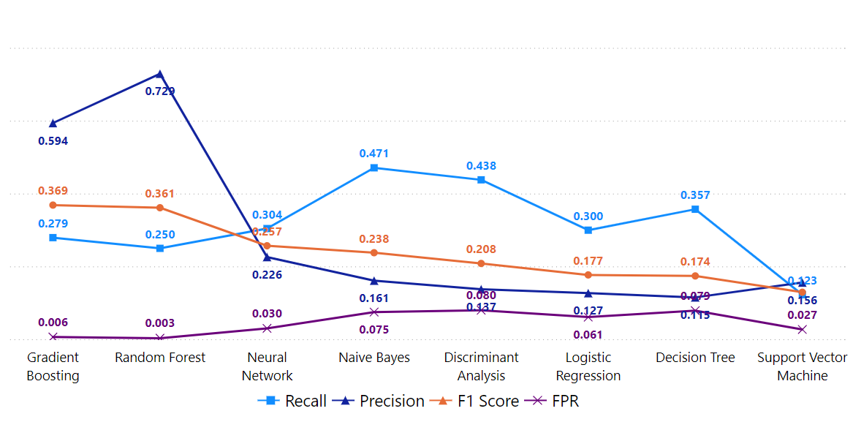

**Figure 11.** Base model comparison based on all features with a dual resampling ratio of 1:1 between the non-cheater and cheater classes.

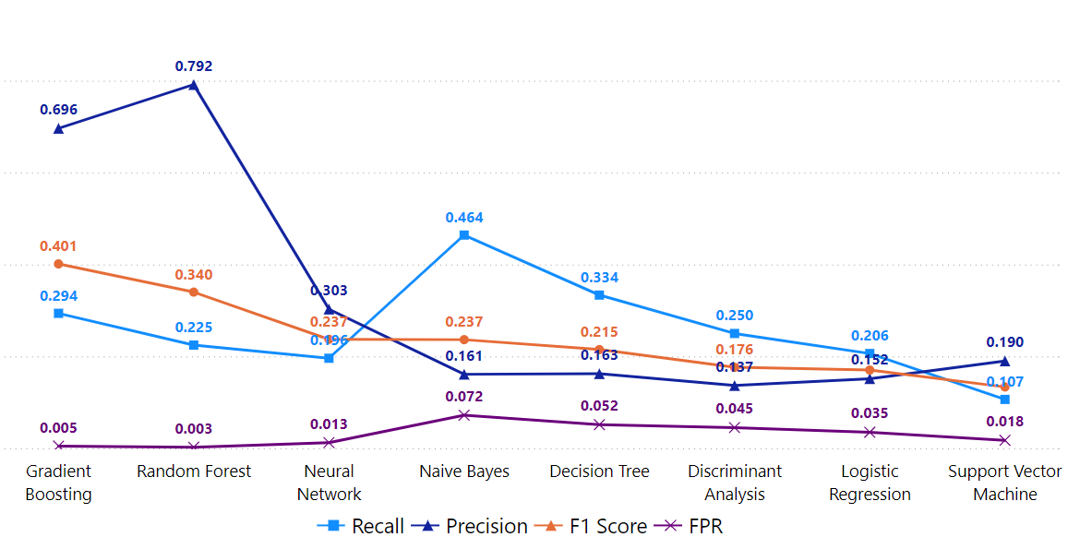

**Figure 12.** Base model comparison based on all features with a dual resampling ratio of 2:1 between the non-cheater and cheater classes.

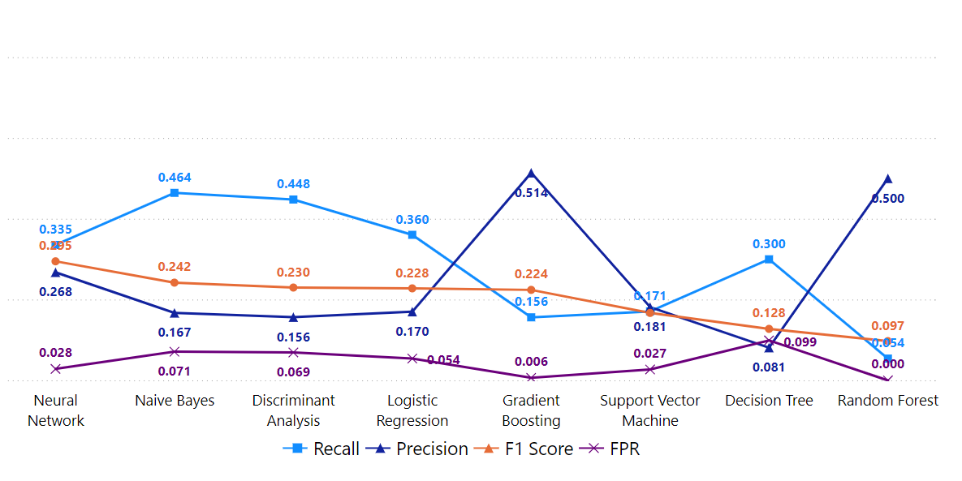

**Figure 26.** Base model comparison based on item response and response time with a dual resampling ratio of 1:1 between the non-cheater and cheater classes.

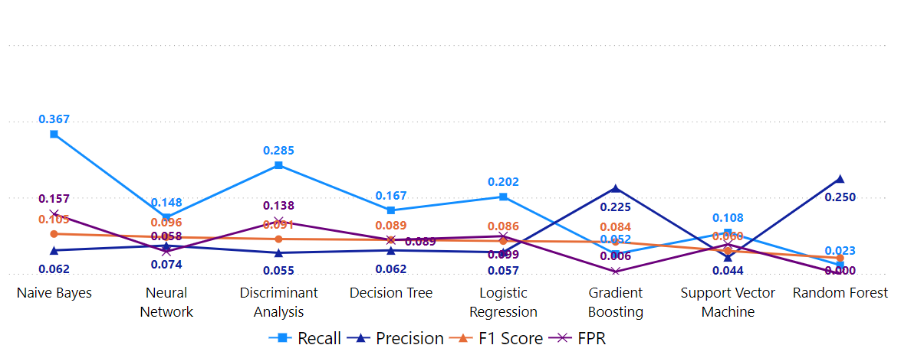

**Figure 27.** Base model comparison based on item response with a dual resampling ratio of 1:1 between the non-cheater and cheater classes.

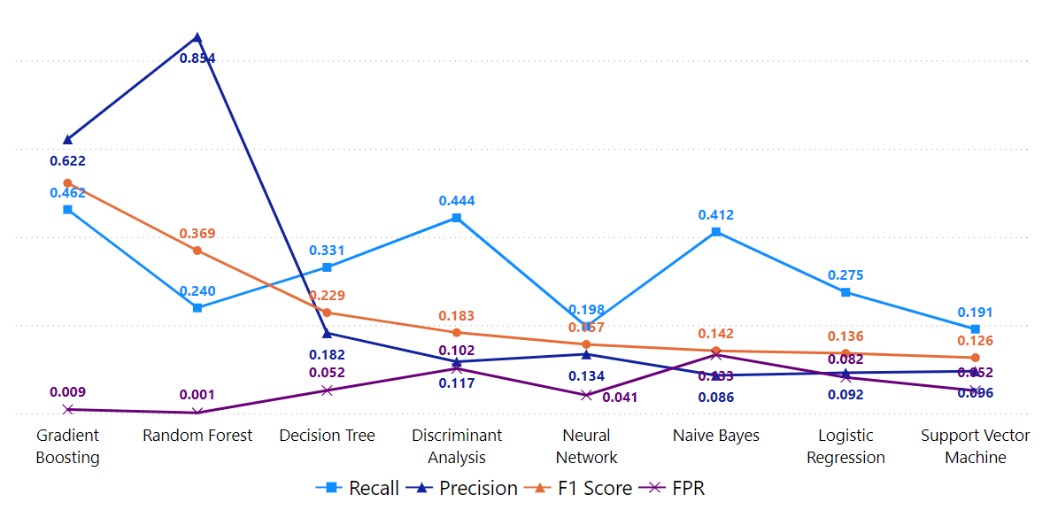

**Figure 28.** Base model comparison based on item response and summative statistics with a dual resampling ratio of 1:1 between the non-cheater and cheater classes.

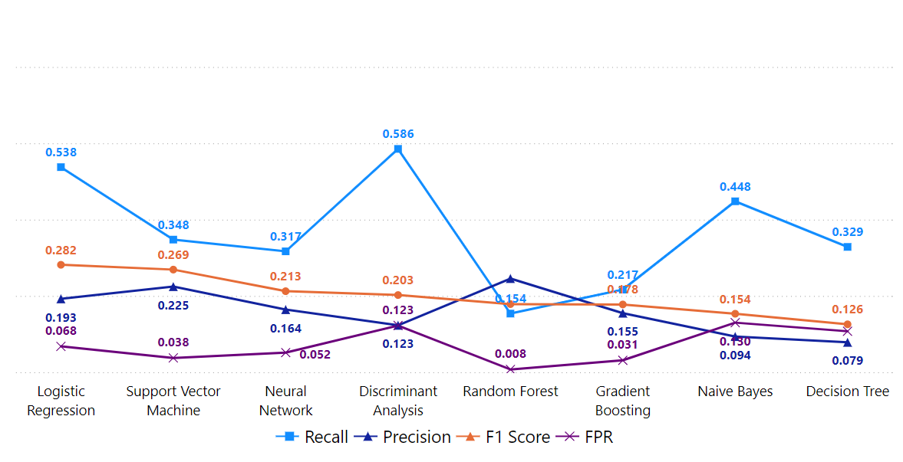

**Figure 29.** Base model comparison based on response time with a dual resampling ratio of 1:1 between the non-cheater and cheater classes.

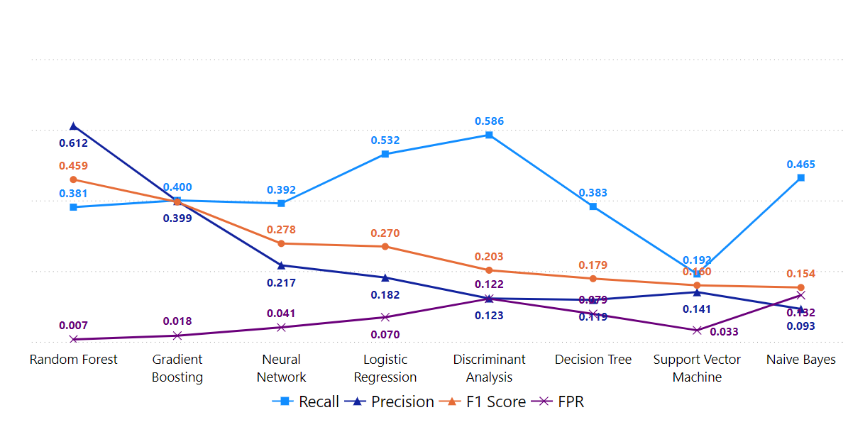

**Figure 30.** Base model comparison based on response time and summative statistics with a dual resampling ratio of 1:1 between the non-cheater and cheater classes.

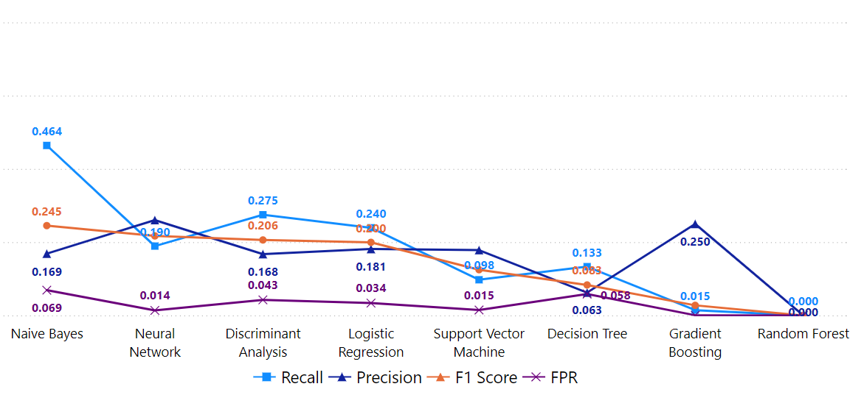

**Figure 31.** Base model comparison based on item response and response time with a dual resampling ratio of 2:1 between the non-cheater and cheater classes.

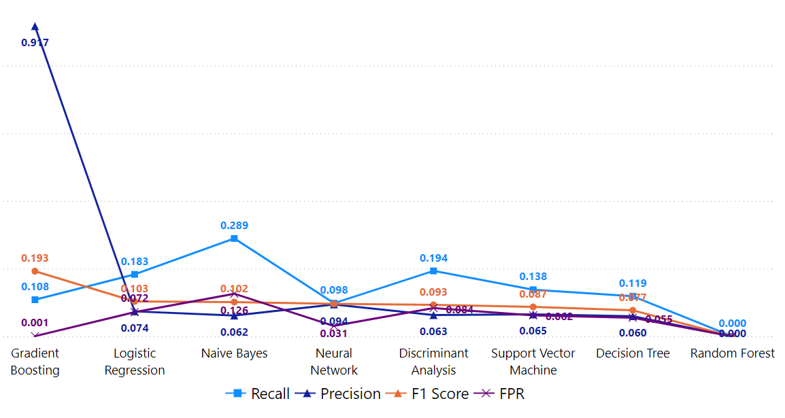

**Figure 32.** Base model comparison based on item response with a dual resampling ratio of 2:1 between the non-cheater and cheater classes.

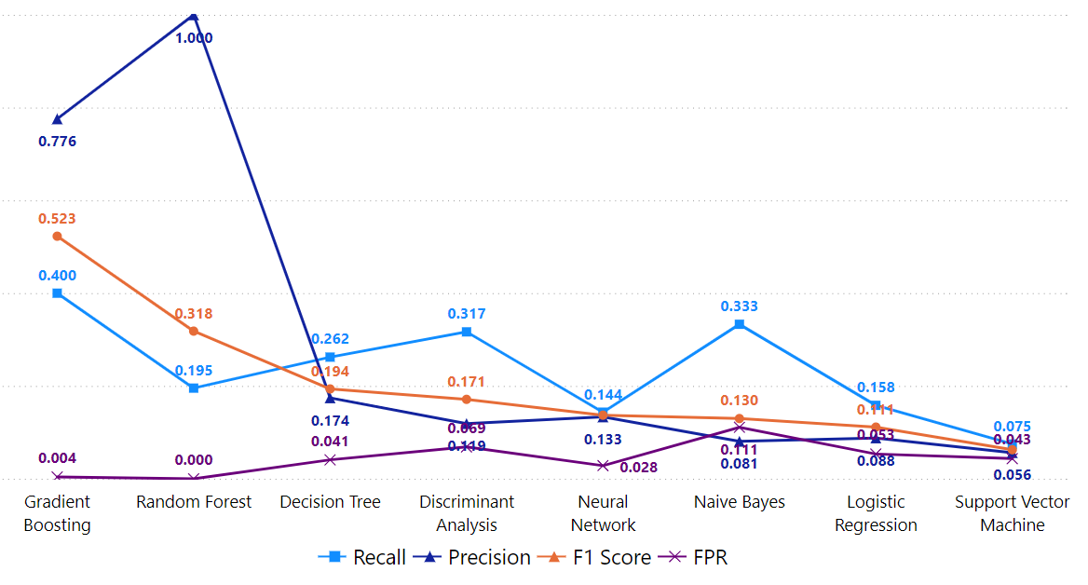

**Figure 33.** Base model comparison based on item response and summative statistics with a dual resampling ratio of 2:1 between the non-cheater and cheater classes.

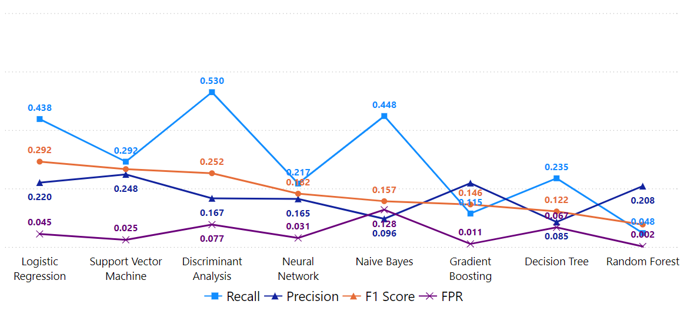

**Figure 34.** Base model comparison based on response time with a dual resampling ratio of 2:1 between the non-cheater and cheater classes.

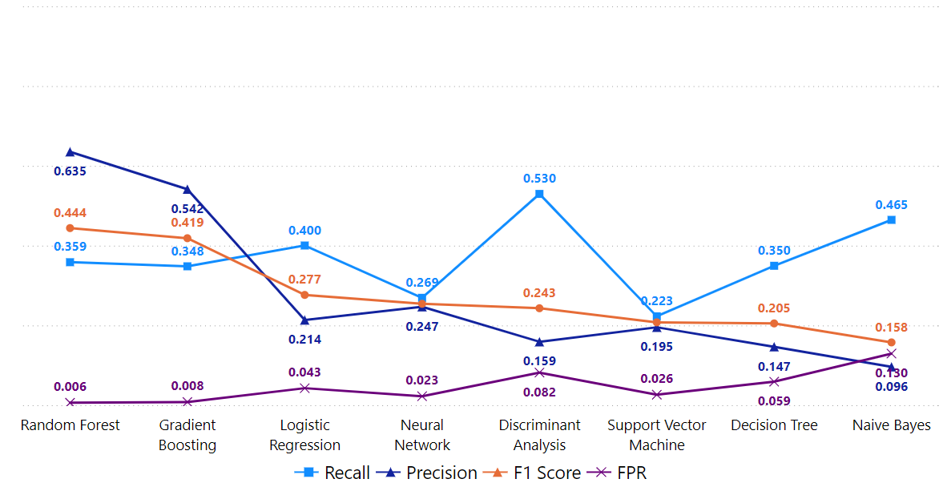

**Figure 35.** Base model comparison based on response time and summative statistics with a dual resampling ratio of 2:1 between the non-cheater and cheater classes.